1). Provision EC2, S3, and VPC using Terraform modules.

Provision EC2, S3, and VPC Using Terraform Modules (Git Bash + AWS)
We’ll create a complete Terraform project using:
- VPC Module
- EC2 Module
- S3 Module
And run everything from Git Bash on Windows.

Project Structure:

terraform-modules-project/
│
├── main.tf
├── variables.tf
├── outputs.tf
├── provider.tf
├── terraform.tfvars
│
├── modules/
│ ├── vpc/
│ │ ├── main.tf
│ │ ├── variables.tf
│ │ └── outputs.tf
│ │
│ ├── ec2/
│ │ ├── main.tf
│ │ ├── variables.tf
│ │ └── outputs.tf
│ │
│ └── s3/
│ ├── main.tf
│ ├── variables.tf
│ └── outputs.tf

Step 1: Install Required Tools
Install:
- Terraform
- AWS CLI
- Git Bash
- Visual Studio Code

Step 2: Configure AWS CLI
Open Git Bash
Run:
aws configure
Enter:
AWS Access Key ID:
AWS Secret Access Key:
Default region name: ap-south-1
Default output format: json
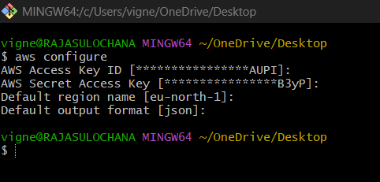
Verify:
aws s3 ls
If no error → AWS configured correctly.
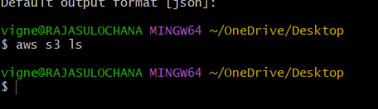

Step 3: Create Project Folder
mkdir terraform-modules-project
cd terraform-modules-project
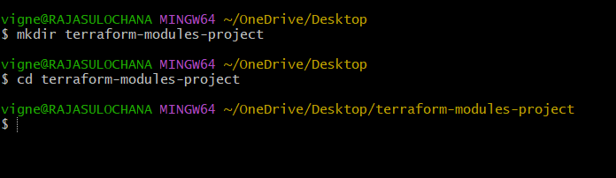
Create folders:
mkdir -p modules/vpc
mkdir -p modules/ec2
mkdir -p modules/s3
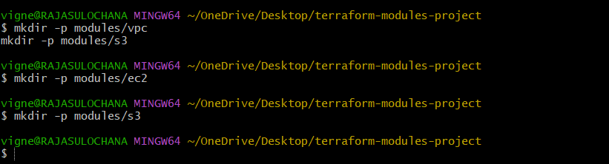

Step 4: Create Root Files
Create files:
touch main.tf variables.tf outputs.tf provider.tf terraform.tfvars
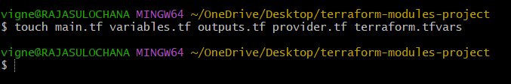

Step 5: Provider Configuration
vi provider.tf
provider "aws" {
region = var.aws_region
}
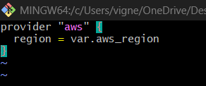

Step 6: Variables File
vi variables.tf
variable "aws_region" {}
variable "vpc_cidr" {}
variable "subnet_cidr" {}
variable "availability_zone" {}
variable "ami_id" {}
variable "instance_type" {}
variable "bucket_name" {}
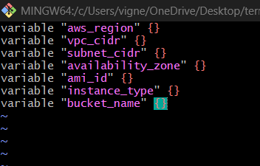

Step 7: Terraform Variable Values
vi terraform.tfvars
aws_region = "eu-north-1"
vpc_cidr = "10.0.0.0/16"
subnet_cidr = "10.0.1.0/24"
availability_zone = "eu-north-1a"
ami_id = " ami-063f61adbae382edf"
instance_type = "t3.micro"
bucket_name = "vignesh-terraform-demo-bucket-12345"
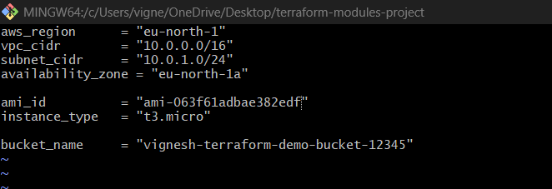
⚠️ S3 bucket name must be globally unique.
Change bucket name if error comes.

Step 8: Create VPC Module
Move to VPC module:
cd modules/vpc
touch main.tf variables.tf outputs.tf
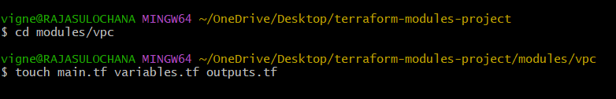

modules/vpc/main.tf
vi main.tf
resource "aws_vpc" "main" {
cidr_block = var.vpc_cidr
tags = {
Name = "Terraform-VPC"
}
}
resource "aws_subnet" "main" {
vpc_id = aws_vpc.main.id
cidr_block = var.subnet_cidr
availability_zone = var.availability_zone
map_public_ip_on_launch = true
tags = {
Name = "Terraform-Subnet"
}
}
resource "aws_internet_gateway" "igw" {
vpc_id = aws_vpc.main.id
tags = {
Name = "Terraform-IGW"
}
}
resource "aws_route_table" "rt" {
vpc_id = aws_vpc.main.id
route {
cidr_block = "0.0.0.0/0"
gateway_id = aws_internet_gateway.igw.id
}
tags = {
Name = "Terraform-RT"
}
}
resource "aws_route_table_association" "rta" {
subnet_id = aws_subnet.main.id
route_table_id = aws_route_table.rt.id
}
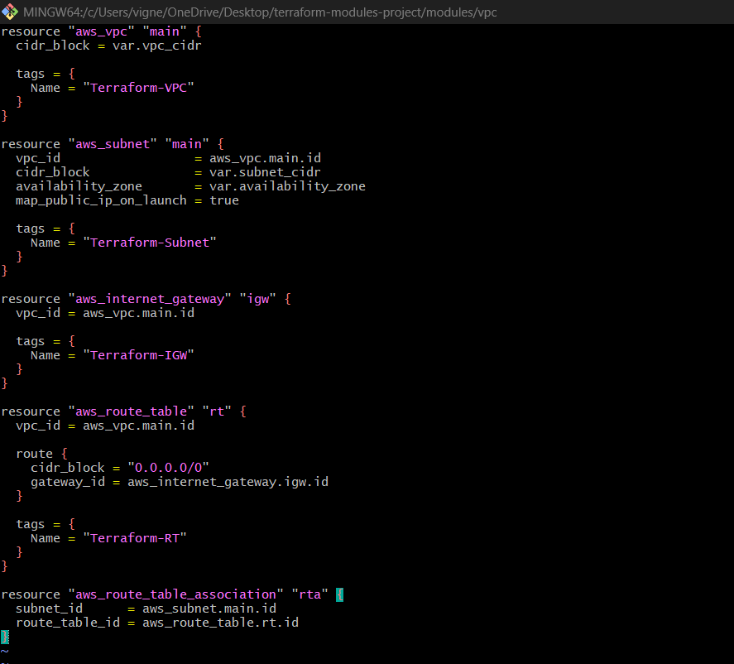

modules/vpc/variables.tf
vi variables.tf
variable "vpc_cidr" {}
variable "subnet_cidr" {}
variable "availability_zone" {}
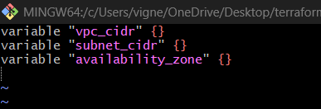

modules/vpc/outputs.tf
vi outputs.tf

output "subnet_id" {
value = aws_subnet.main.id
}
output "vpc_id" {
value = aws_vpc.main.id
}
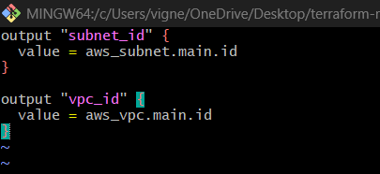

Step 9: Create EC2 Module
Go back:
cd ../ec2
touch main.tf variables.tf outputs.tf
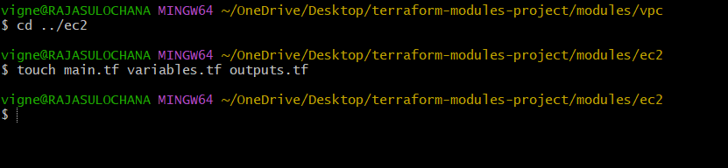

modules/ec2/main.tf
vi main.tf
resource "aws_security_group" "sg" {
name = "terraform-sg"
description = "Allow SSH"
vpc_id = var.vpc_id
ingress {
from_port = 22
to_port = 22
protocol = "tcp"
cidr_blocks = ["0.0.0.0/0"]
}
ingress {
from_port = 80
to_port = 80
protocol = "tcp"
cidr_blocks = ["0.0.0.0/0"]
}
egress {
from_port = 0
to_port = 0
protocol = "-1"
cidr_blocks = ["0.0.0.0/0"]
}
}
resource "aws_instance" "ec2" {
ami = var.ami_id
instance_type = var.instance_type
subnet_id = var.subnet_id
vpc_security_group_ids = [aws_security_group.sg.id]
user_data = <<-EOF
#!/bin/bash
yum install httpd -y
systemctl start httpd
systemctl enable httpd
echo "Terraform EC2 Working" > /var/www/html/index.html
EOF
tags = {
Name = "Terraform-EC2"
}
}
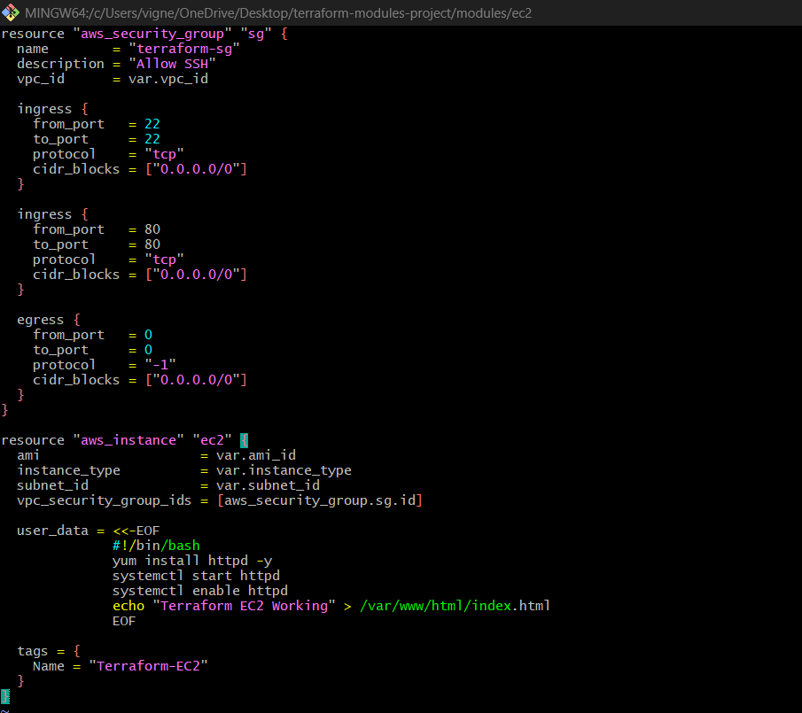

modules/ec2/variables.tf
vi variables.tf
variable "ami_id" {}
variable "instance_type" {}
variable "subnet_id" {}
variable "vpc_id" {}
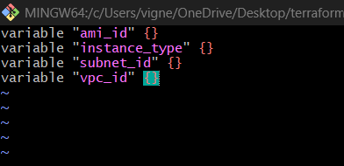

modules/ec2/outputs.tf
vi outputs.tf
output "public_ip" {
value = aws_instance.ec2.public_ip
}
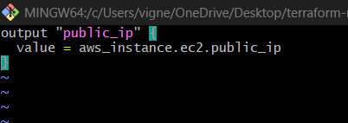

Step 10: Create S3 Module
cd ../s3
touch main.tf variables.tf outputs.tf
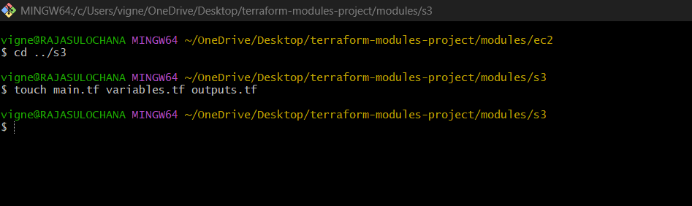

modules/s3/main.tf
vi main.tf
resource "aws_s3_bucket" "bucket" {
bucket = var.bucket_name
tags = {
Name = "Terraform-S3"
}
}
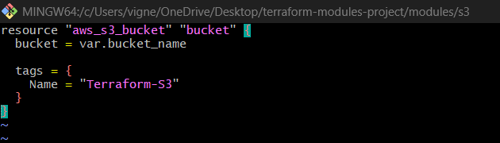

modules/s3/variables.tf
vi variables.tf
variable "bucket_name" {}
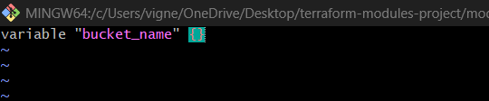

modules/s3/outputs.tf
vi outputs.tf
output "bucket_name" {
value = aws_s3_bucket.bucket.bucket
}
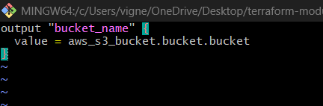

Step 11: Root main.tf
Go back:
cd ../../
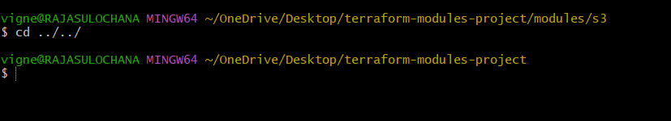

vi main.tf
module "vpc" {
source = "./modules/vpc"
vpc_cidr = var.vpc_cidr
subnet_cidr = var.subnet_cidr
availability_zone = var.availability_zone
}
module "ec2" {
source = "./modules/ec2"
ami_id = var.ami_id
instance_type = var.instance_type
subnet_id = module.vpc.subnet_id
vpc_id = module.vpc.vpc_id
}
module "s3" {
source = "./modules/s3"
bucket_name = var.bucket_name
}
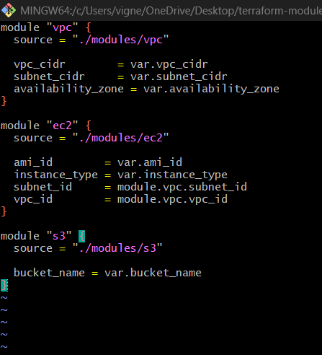

Step 12: Outputs
vi outputs.tf
output "ec2_public_ip" {
value = module.ec2.public_ip
}
output "bucket_name" {
value = module.s3.bucket_name
}
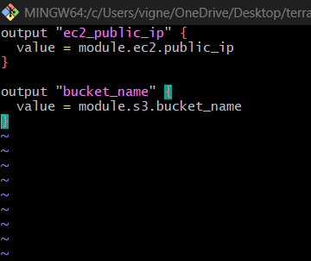

Step 13: Initialize Terraform
Run:
terraform init
Expected:
Terraform has been successfully initialized!
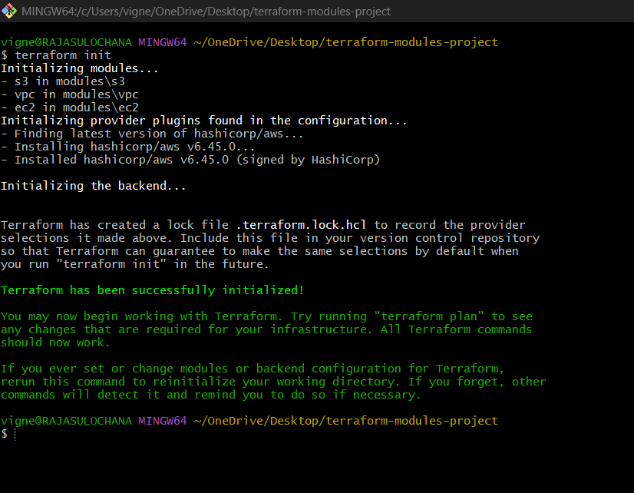

Step 14: Validate Configuration
terraform validate
Expected:
Success! The configuration is valid.
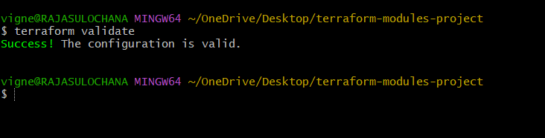

Step 15: Preview Infrastructure
terraform plan

You should see:
- 1 VPC
- 1 Subnet
- 1 IGW
- 1 Route Table
- 1 EC2
- 1 Security Group
- 1 S3 Bucket
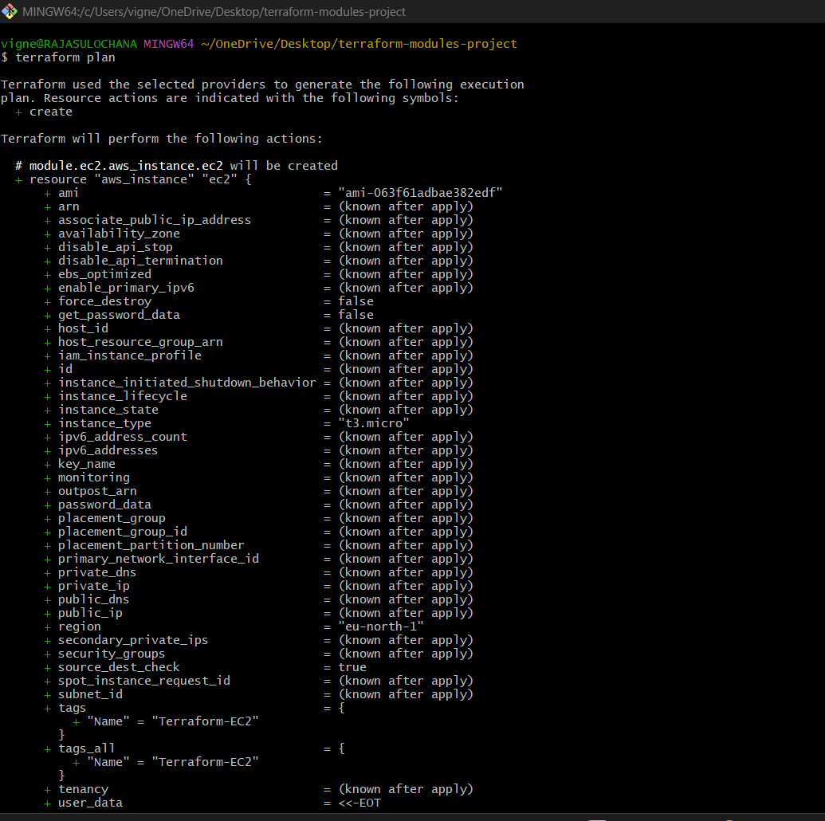
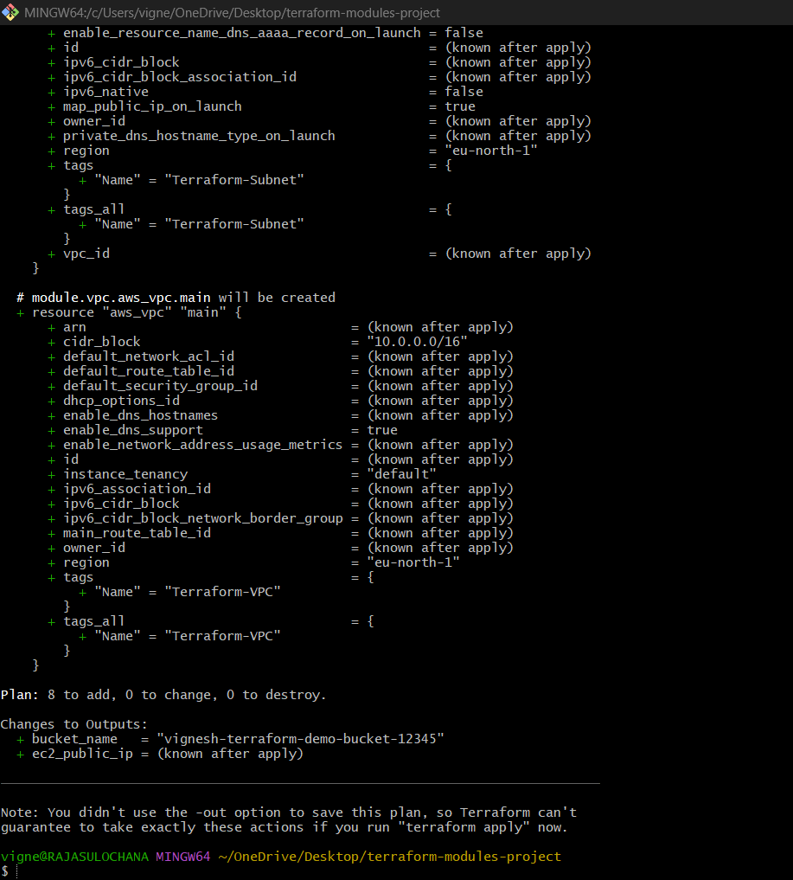

Step 16: Create Infrastructure
terraform apply
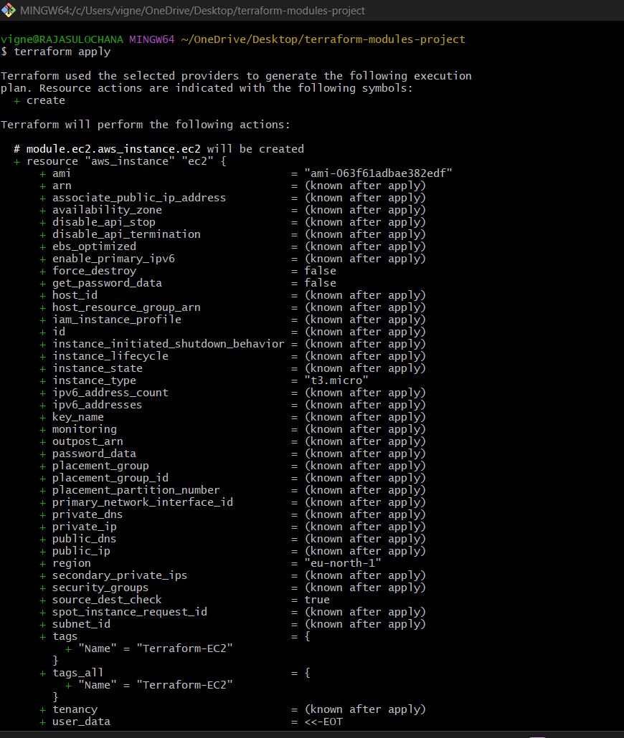
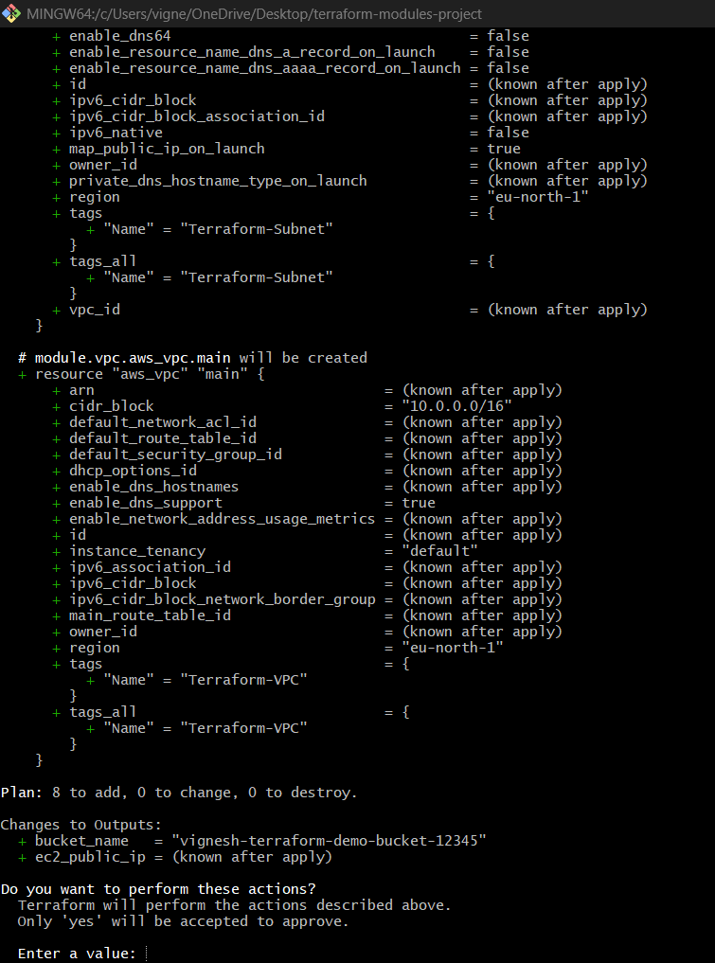
Type:
yes
Wait 1–2 minutes.
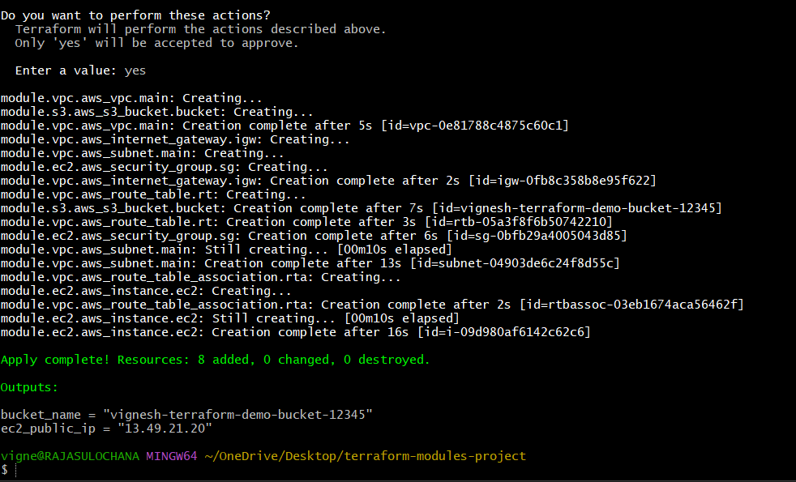

Step 17: Verify Resources
Check EC2
AWS Console → EC2 → Instances
You’ll see:
Terraform-EC2
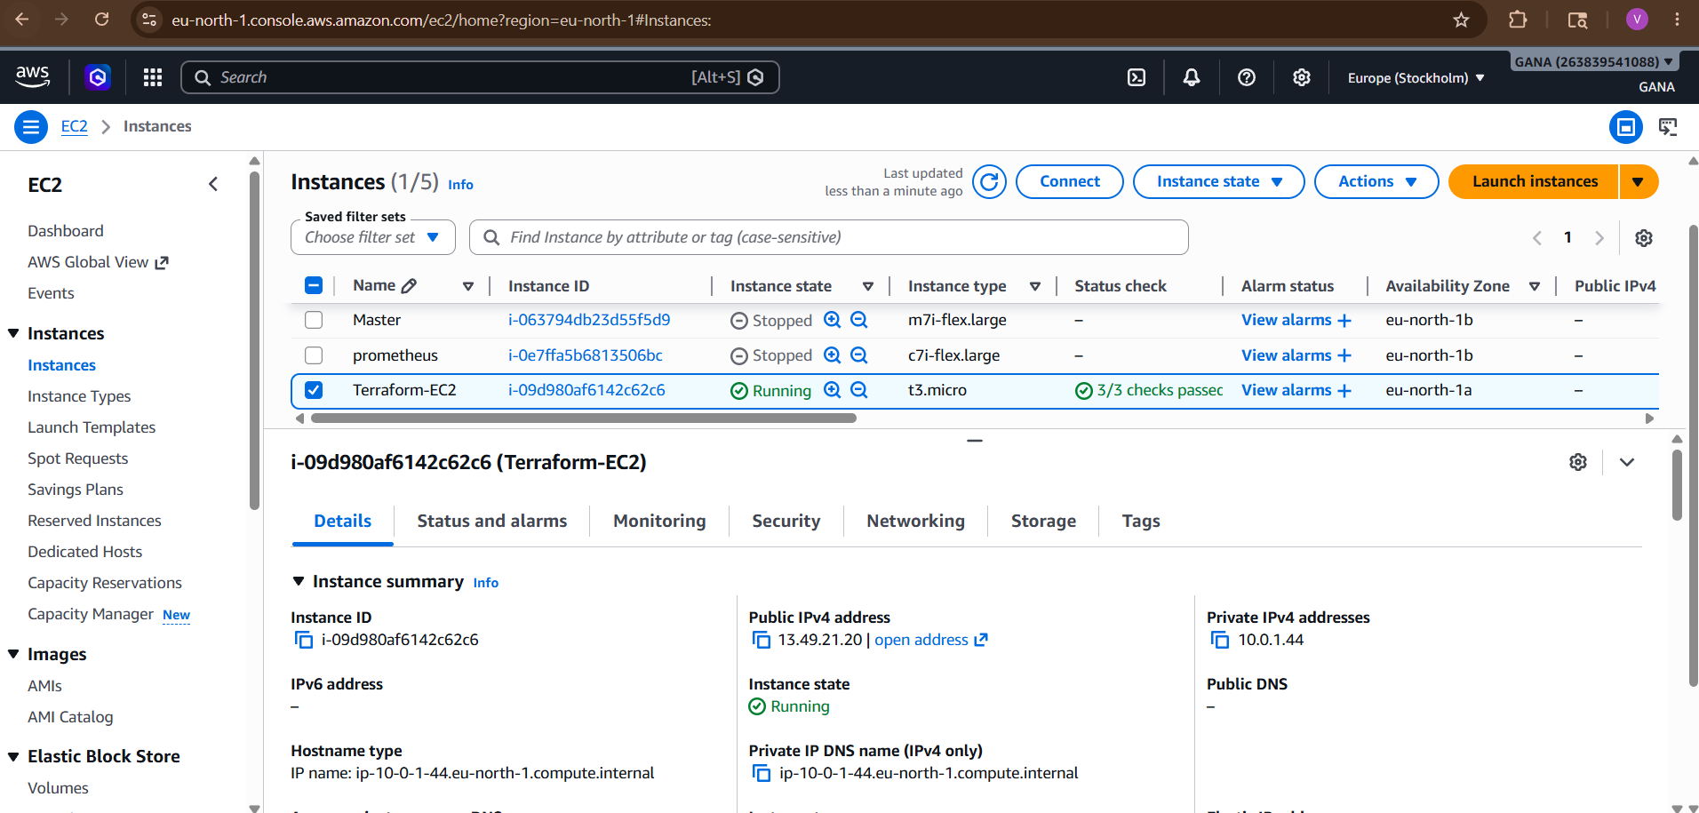

Check EC2
AWS Console → EC2 → Security Groups
You’ll see:
sg-0bfb29a4005043d85 - terraform-sg
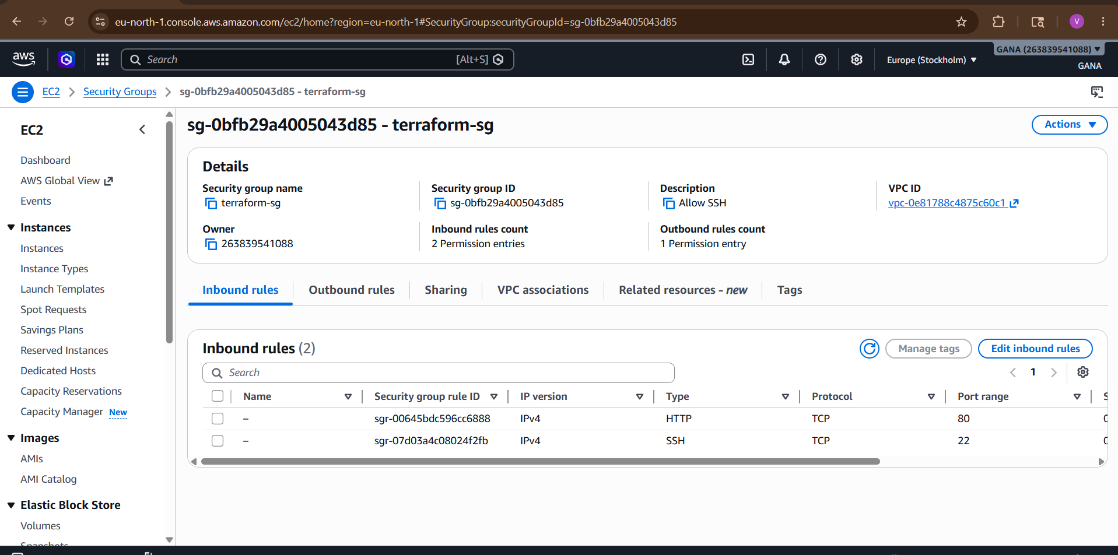
Check S3
AWS Console → S3
You’ll see your bucket.
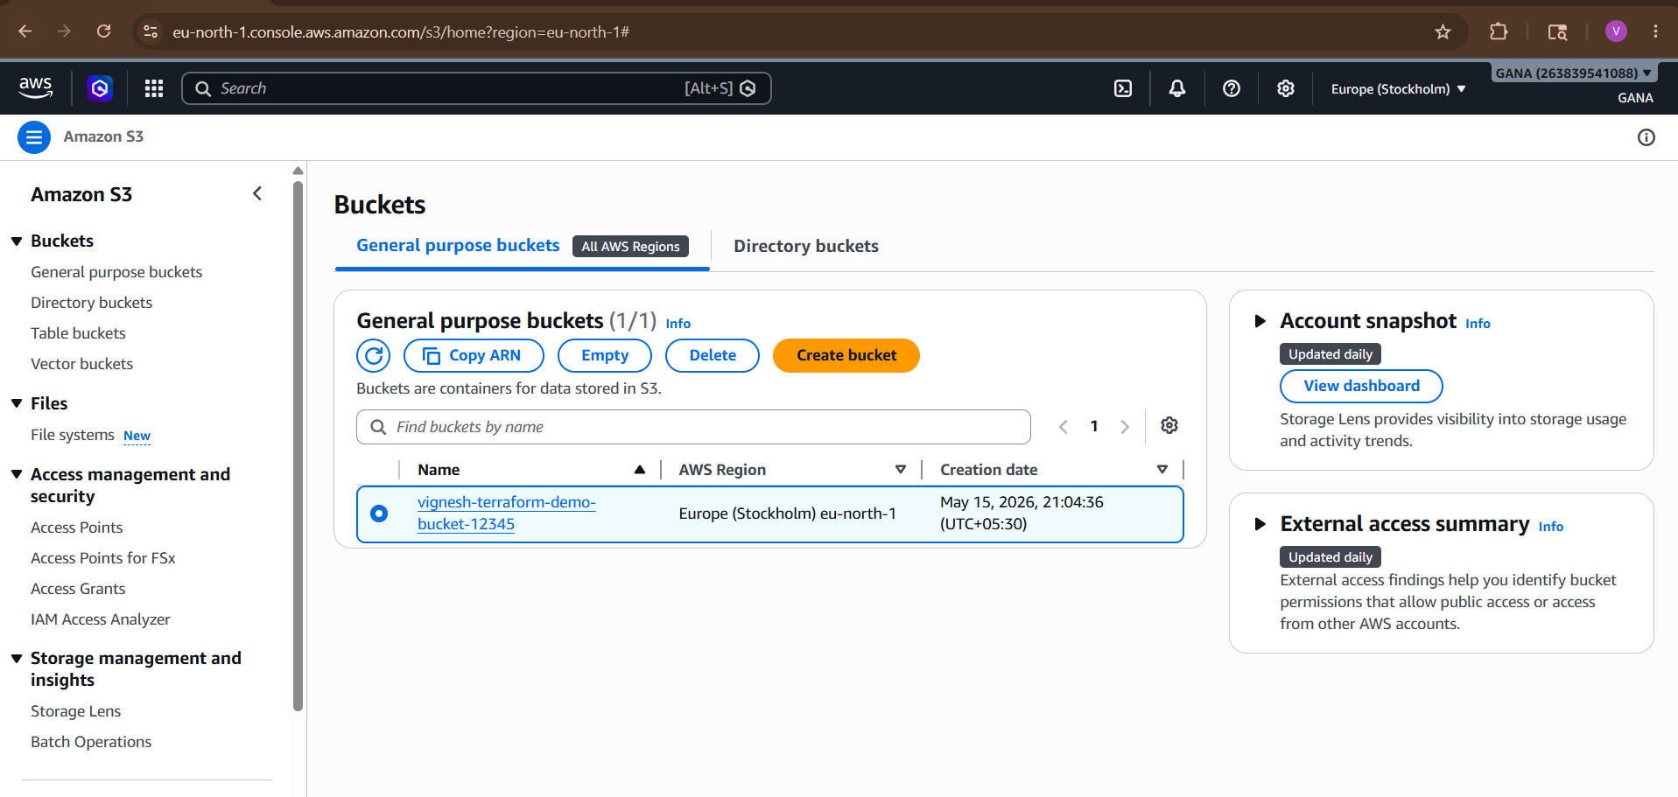
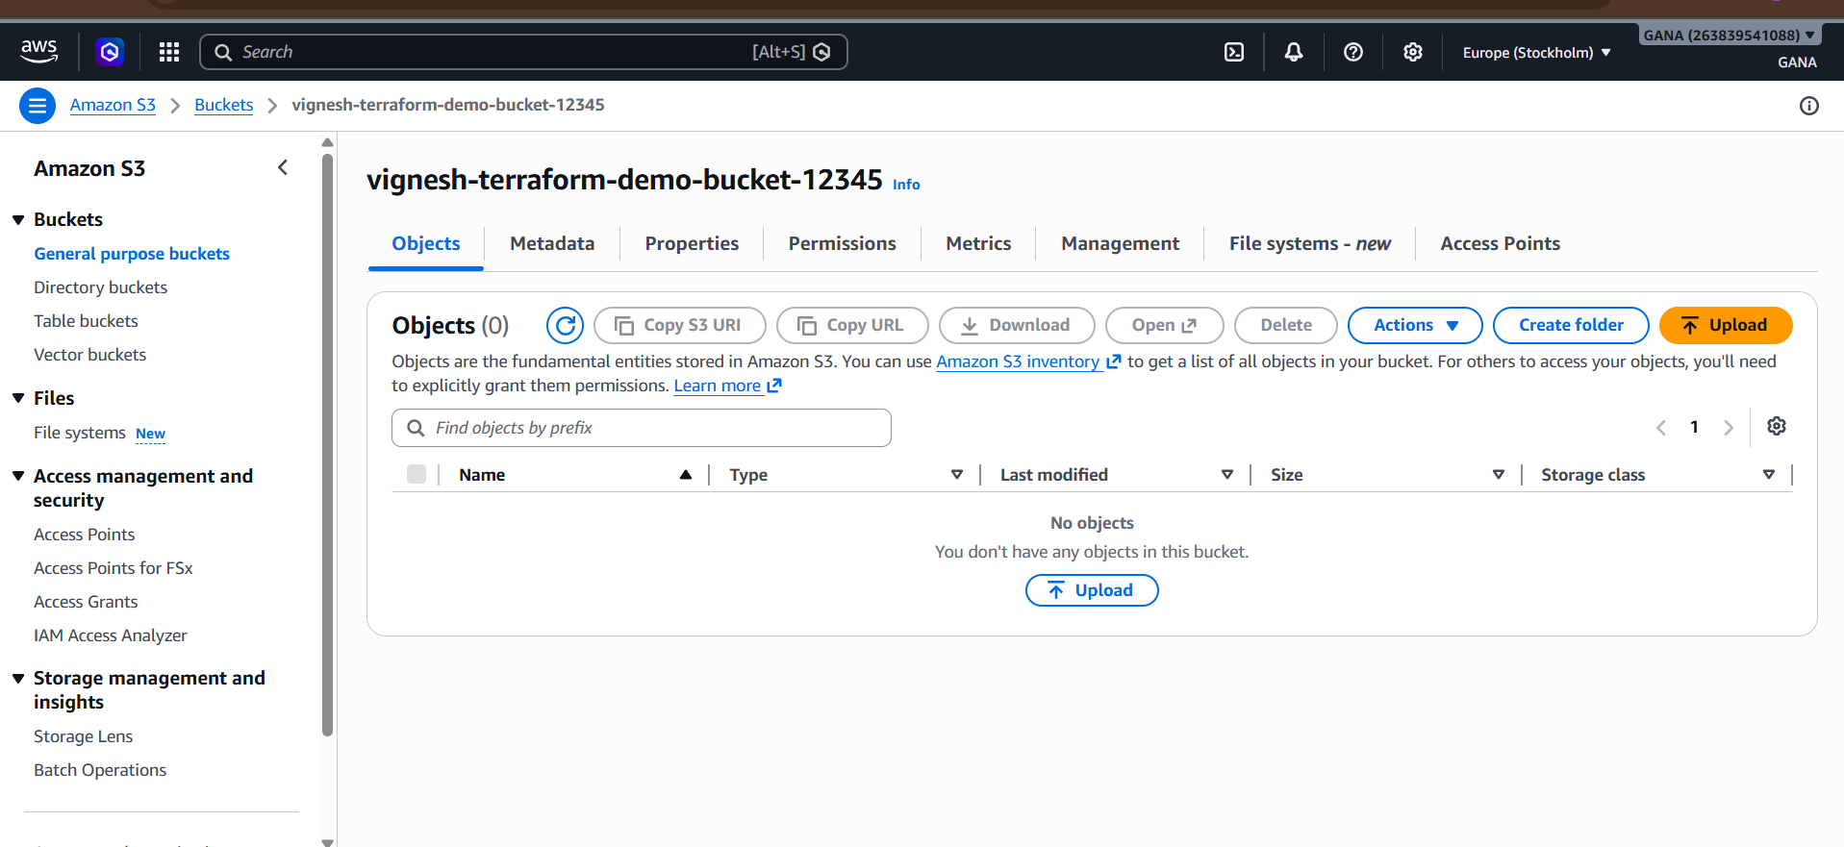

Test Apache Server
Copy EC2 public IP.
Open browser:
http://YOUR_PUBLIC_IP
http://13.49.21.20/

Output:
Terraform EC2 Working
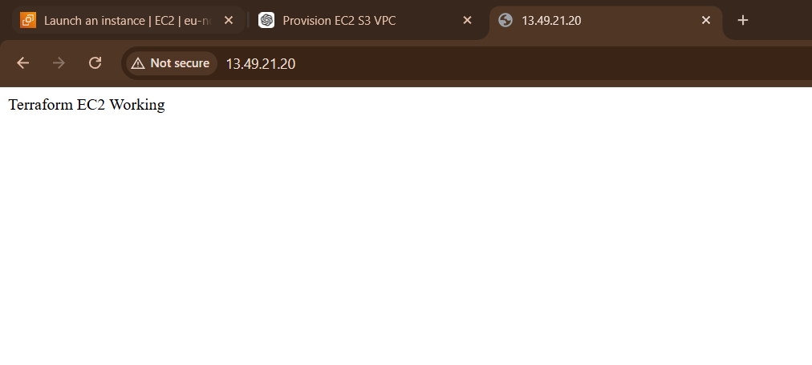

Infrastructure working successfully.

Step 18: Destroy Infrastructure
To avoid AWS charges:
terraform destroy
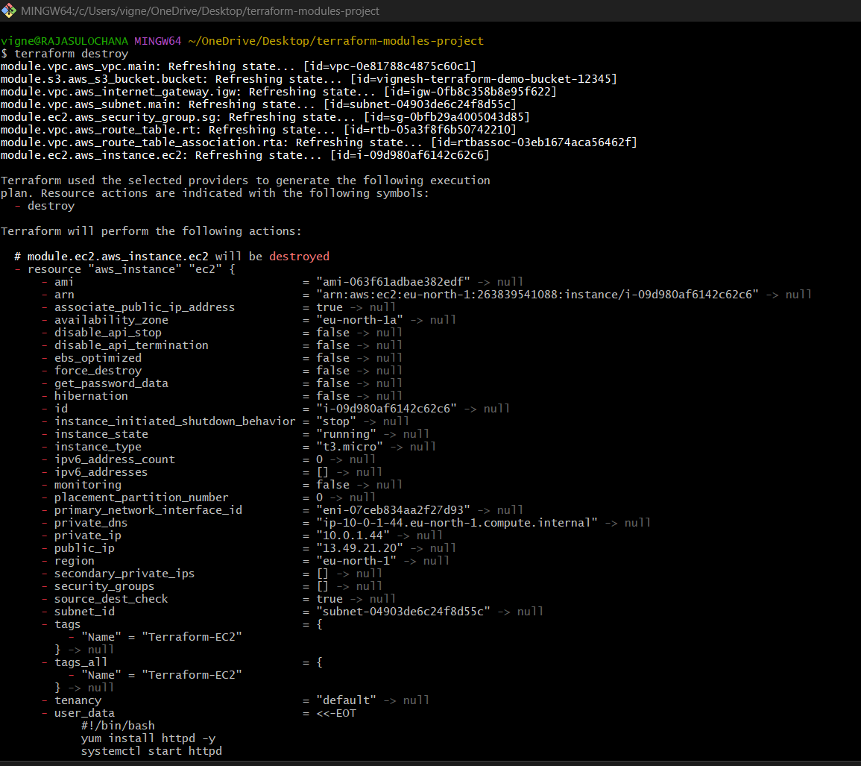

Type:
Yes
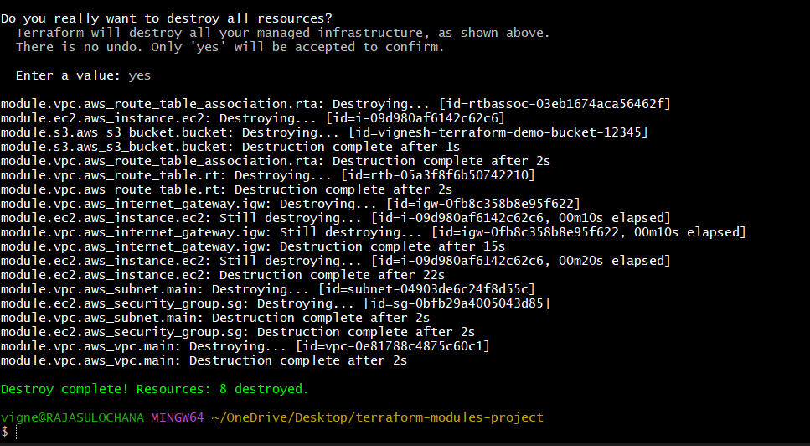
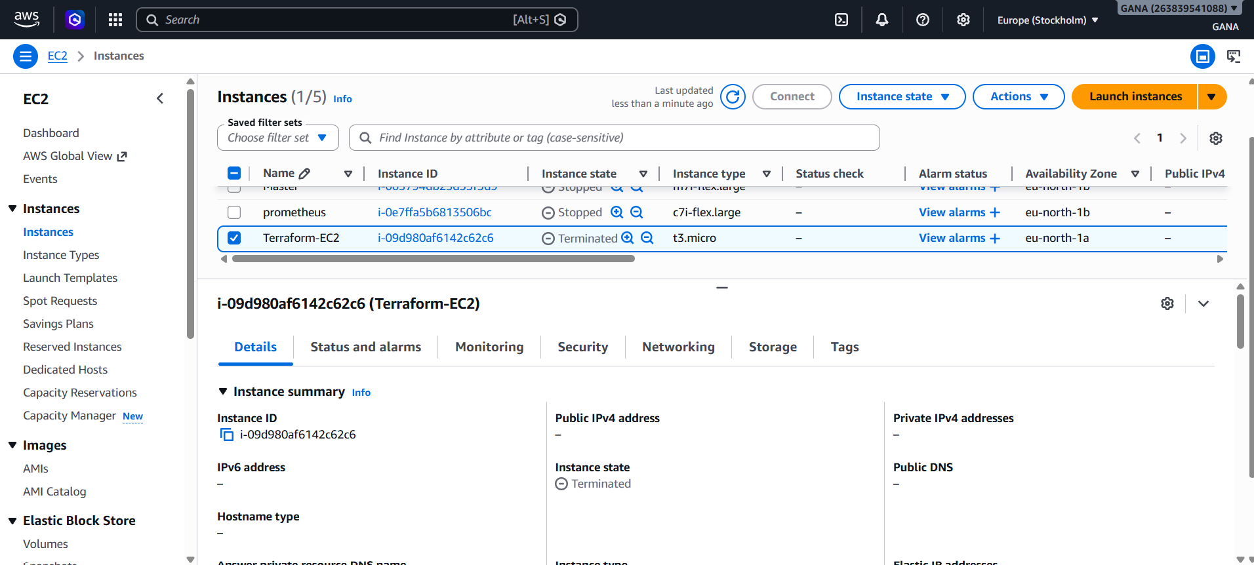

Important Terraform Commands
Command | Purpose
terraform init | Initialize project
terraform validate | Validate syntax
terraform plan | Preview changes
terraform apply | Create resources
terraform destroy | Delete resources
terraform fmt | Format code

Common Errors Fix
Bucket Already Exists
Change:
bucket_name = "new-unique-name-123"

Invalid AMI
Use latest Amazon Linux 2 AMI for your region.

Authentication Error
Run again:
aws configure

Final Result
You created using Terraform Modules:
✅ VPC
✅ Subnet
✅ Internet Gateway
✅ Route Table
✅ EC2 Instance
✅ Security Group
✅ Apache Web Server
✅ S3 Bucket

2). Provision EC2 for 3 different environments (Dev, Staging, and Prod) using Terraform workspaces

Project Structure
terraform-workspaces-project/
│
├── main.tf
├── variables.tf
├── outputs.tf
└── terraform.tfvars

Use one Terraform code and create 3 workspaces: dev, staging, prod.
- Create main.tf

provider "aws" {
region = "eu-north-1"
}
locals {
env_config = {
dev = {
instance_type = "t3.micro"
name = "Dev-EC2"
}
staging = {
instance_type = "t3.micro"
name = "Staging-EC2"
}
prod = {
instance_type = "t3.small"
name = "Prod-EC2"
}
}
current_env = terraform.workspace
}
resource "aws_instance" "web_server" {
ami = "ami-063f61adbae382edf"
instance_type = local.env_config[local.current_env].instance_type
tags = {
Name = local.env_config[local.current_env].name
Environment = local.current_env
}
}
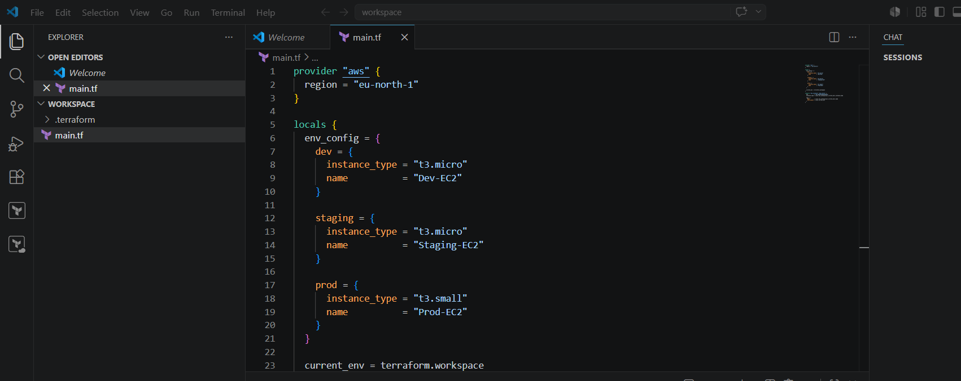
2. Initialize Terraform
terraform init
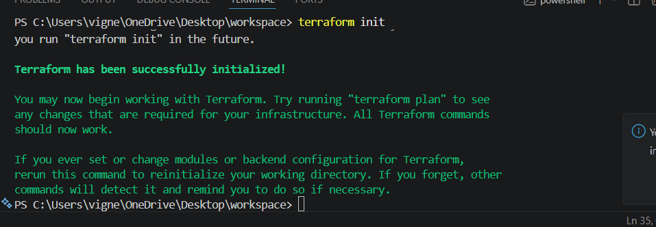
3. Create workspaces
terraform workspace new dev
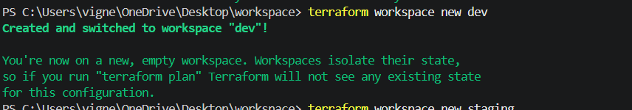
terraform workspace new staging
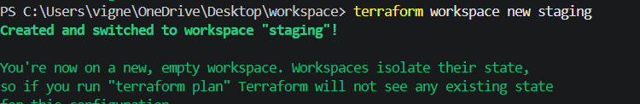

terraform workspace new prod
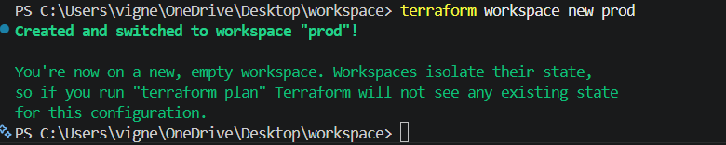

4. Create Dev EC2
terraform workspace select dev
terraform apply -auto-approve
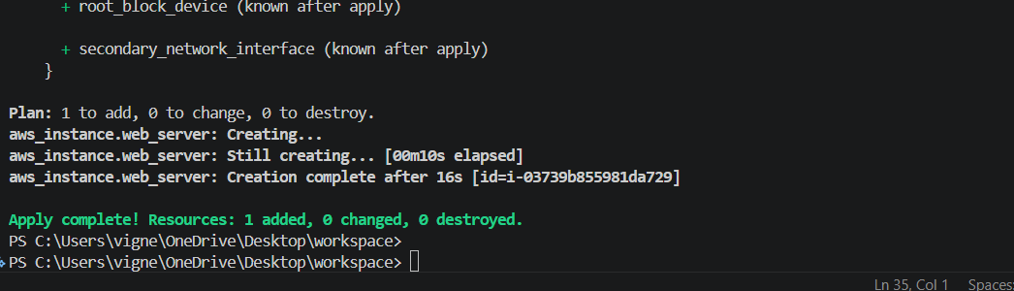

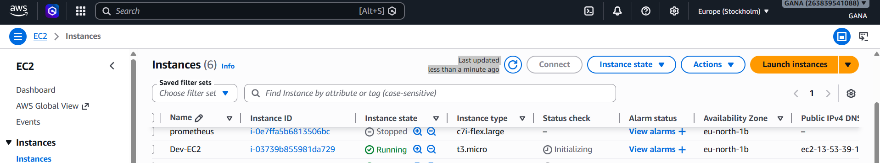

5. Create Staging EC2
terraform workspace select staging
terraform apply -auto-approve
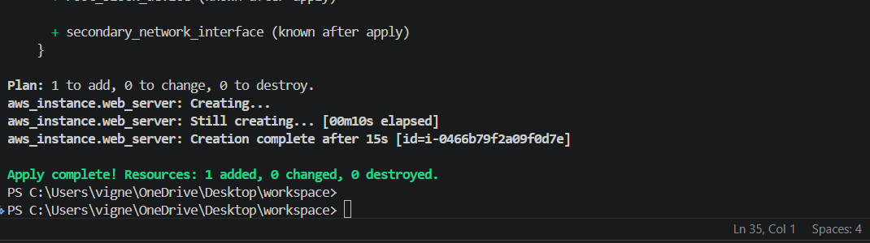

6. Create Prod EC2
terraform workspace select prod
terraform apply -auto-approve

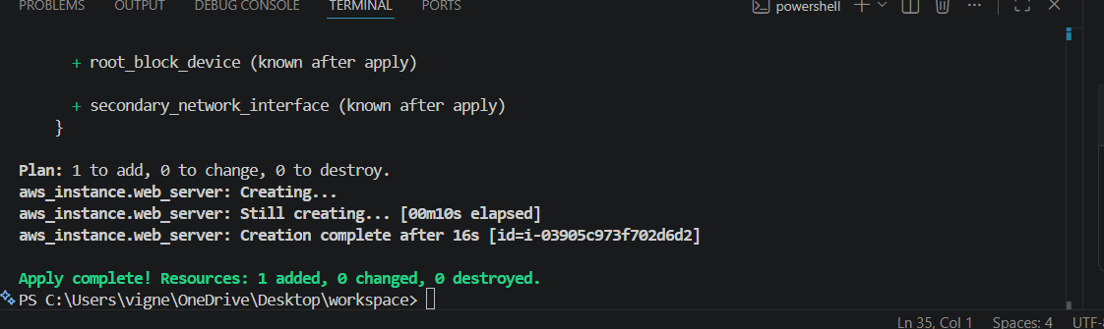

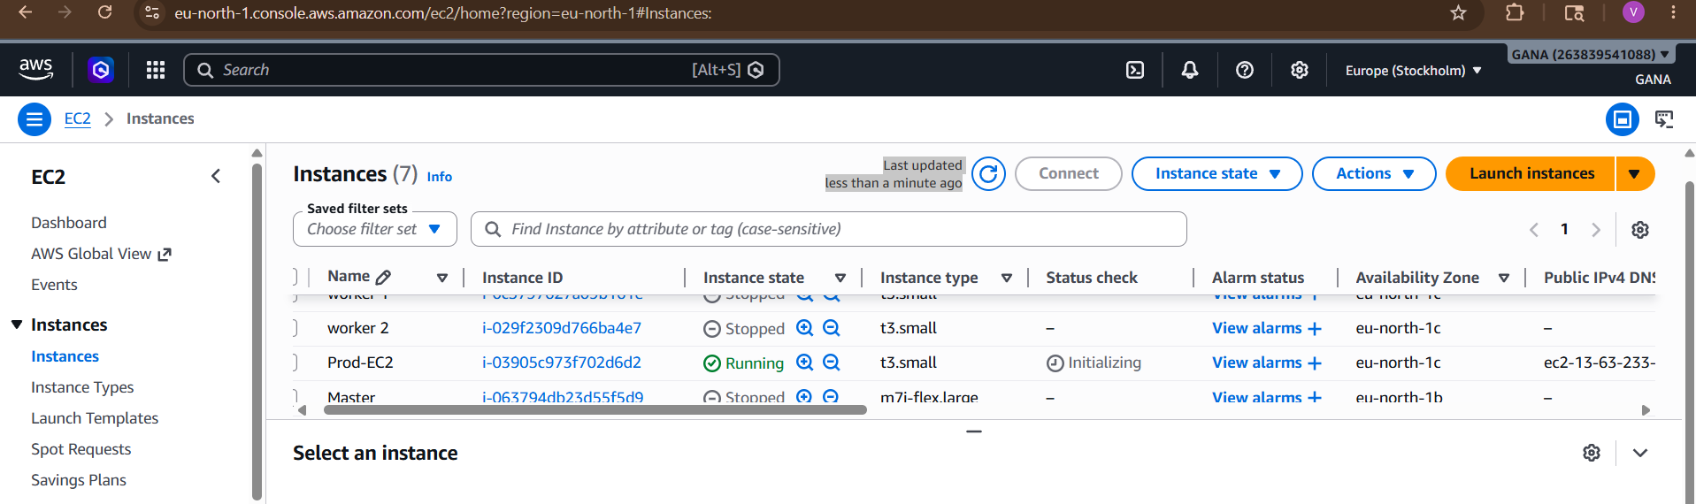

7. Check current workspace
terraform workspace show

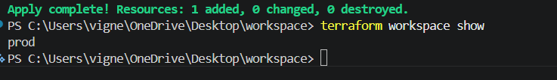

8. List all workspaces
terraform workspace list

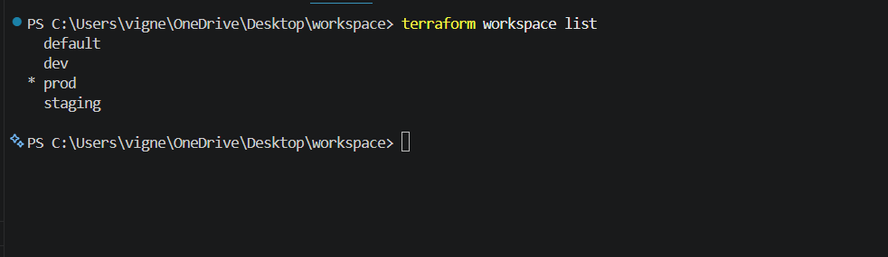

9. Destroy environment-wise
Dev:
terraform workspace select dev
terraform destroy -auto-approve
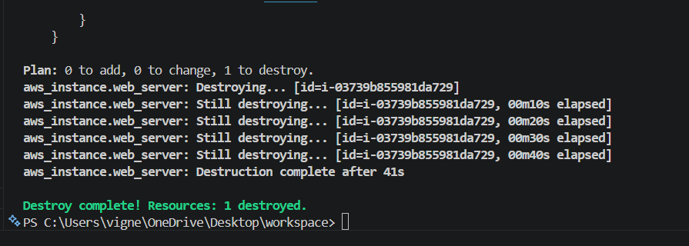
Staging:
terraform workspace select staging
terraform destroy -auto-approve
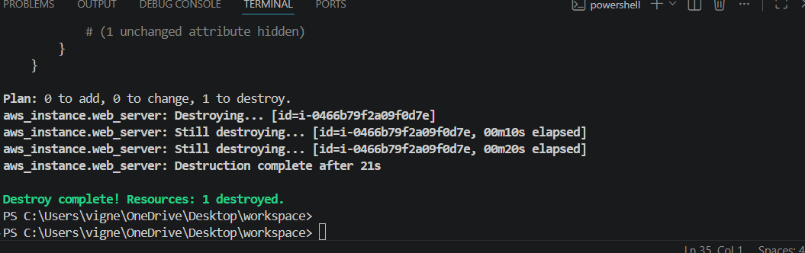
Prod:
terraform workspace select prod
terraform destroy -auto-approve
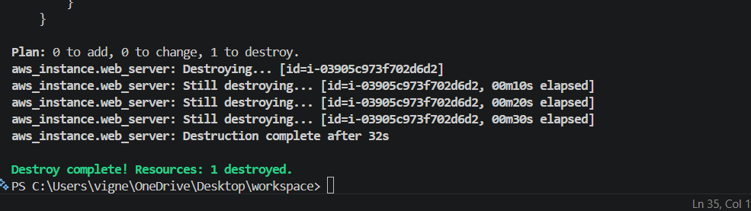
Important Commands
List Workspaces
terraform workspace list
Select Workspace
terraform workspace select dev
Create Workspace
terraform workspace new prod
Delete Workspace
terraform workspace delete dev
Expected Result
Workspace | EC2 Name | Instance Type
dev | Dev-Server | t3.micro
staging | Staging-Server | t3.micro
prod | Prod-Server | t3.small

